GENSANTOS FOUNDATION COLLEGE INC.

Bulaong, Extension, General Santos City

**ENHANCED INVENTORY MANAGEMENT SYSTEM**

COLLEGE OF INFORMATION TECHNOLOGY EDUCATION



A Capstone Project

Presented to the faculty of Information System

College of Information technology Education Department

In Partial fulfillment of the requirement for the degree

Bachelor of Science in Information System

**Submitted by;**

Collamar, John Albert B.

Valle, Chynna Claire C.

Suetado, Richmond B.

Data, Johnmyr M.

**JUNE 2024**

**ENHANCED INVENTORY MANAGEMENT SYSTEM**

**COLLAMAR, JOHN ALBERT B.**

**VALLE, CHYNNA CLAIRE C.**

**SUETADO, RICHMOND B.**

**DATA, JOHNMYR M.**



**COLLEGE OF INFORMATION TECHNOLOGY EDUCATION**

**GENSANTOS FOUNDATION COLLEGE INC.**

**JUNE 2024**

RECOMMENDATION SHEET

The Capstone Project entitled, “**ENHANCED INVENTORY MANAGEMENT SYSTEM**” for GENSANTOS FOUNDATION COLLEGE INC**.** Submitted by the proponents John Albert Collamar, Johnmyr Data, Richmond Suetado and Chynna Claire Valle has been reviewed and evaluated to proceed for Oral Defense.

**JOHN MICHAEL B. TAN, MIT**

Capstone Adviser

_________________

Date of Approval

CERTIFICATE OF AUTHENTICITY AND ORIGINALITY

This is to certify that We the authors of this Capstone project, “**ENHANCED INVENTORY MANAGEMENT SYSTEM FOR GENSANTOS FOUNDATION COLLEGE, INC** ”,is hereby certify and vouch that the contents of this research project is solely our own original work; that no part of this study has been copied nor taken without due permission or proper acknowledgment and citation of the respective authors; that we are upholding academic professionalism by integrating intellectual property rights laws in research and projects as requirements to our program.

If found and proven that there is an attempt or committed an infringement of copyright ownership, we are liable for any legal course of action sanctioned by the University and the Philippine laws.

PROPONENTS:

**VALLE, CHYNNA CLAIRE C.**

**DATA, JOHNMYR M.**

**COLLAMAR, JOHN ALBERT B.**

**SUETADO, RICHMOND B.**

**ACKNOWLEDGEMENT**

We would like to take this opportunity to acknowledge and express our gratitude to the people and organizations that have provided extraordinary assistance and participation during the development of our capstone project

First, we would like to thank our capstone adviser, **John Michael B. Tan, MIT** for valuable guidance, as well as a full support and expertise throughout the project. His insights and feedback have been instrumental in shaping our project for ensuring its success.

Also, we would also like to extend our gratitude and appreciation to the panel member of the board **Mrs. Sanrio Gumban** and **Mr. Ralph Tanting** who provided us a constructive feedback and challenged to think critically about our project. Their input has helped us improve the quality of our work.

The researcher, would like to thank other researchers and experts in the field of Inventory System who provided us with valuable insights, resources, and feedback. Their contributions have greatly enriched our project and expanded our knowledge in the field.

We are grateful to our family and friends who supported us with emotional support and encouragement throughout the project. Their unwavering support has been a source of our motivation and inspiration to this challenge.

Moreover, we would like to express our sincere thankfulness to Ms. **Charlotte C. Lapura** and colleagues for their great contribution to the development of our Enhanced Inventory Management system for Gensantos Foundation College Inc. Their willingness to provide us with important data and information has been instrumental in shaping the functionality and effectiveness of our solution.

Finally, we would like to acknowledge the blessings and guidance of God, without whom this project would not have been possible, His grace and mercy have sustained us through the challenges of this project and we give Him all the glory.

**Table of Contents**

Recommendation Sheet

Approval Sheet

Certificate of Authenticity and Originality

Acknowledgement

Executive Summary

**TABLE OF CONTENTS**

**Executive Summary**

**Chapter I**

**Introduction**……………………………………………………………………………………………………………..…………….1

Project Context……………………………………………………………………………………………………………………….2

Purpose and Description………………………………….……………………………………………………………………..4

Objective……………………………………………………………………………………………………..…………………………..6

Scope and Limitation………………………………………………………………………………………………………….…….7

**Chapter II Review of Related Literature, Studies and Technologies**

Conceptual framework……………………………………………………………………………………………………….……11

Review of Related Literature ………………………………………………………………….…………….………………..13

Review of Related Studies…………………………………………………………………………………………………….….16

**Chapter III. Technical Background**

Technicality of the Project…………………………………………………………….………20

Details of Technology to be Used……………………………………..……………………..21

How the Project Will Work……………………………………………….……………………21

**EXECUTIVE SUMMARY**

This executive summary provides a concise overview of the Enhanced Inventory management system that has been recommended for installation at our institution. The system seeks to simplify and automate inventory procedures, optimizing efficiency and accuracy while eradicating labor intensive tasks. The following key aspects focus on several essential elements of the system:

Key Features Overview:

* Purpose: Implementing a generated barcode enhancement to modernize the output of Inventory Management system to optimize and accomplish technological advancement of the school.
* Data Transmission. Capable of transferring Inventory record automatically from specific organization to another all through the operation of the system.
* Supplier Details. The system is visible to examine all partnership, stakeholders and supplier’s availability for the certain Items and equipment that the school can avail and purchased.
* Benefits: includes efficiency in tasks productivity, reduced human errors and provide substantial automated aspects of technology in Inventory management for greater data security enhancement to provide a compliance with labor law standards.

System Features:

* Employee Information Access. Centralized data base management to Generate reports and organize data collection accordingly to the institution standards including printed reports, accountability of equipment, Ownership and summary of Inventory reports.
* Automated Record Keeping. To provide reliable evidence of information for data tracking and resources as a main requirement to ensure records is updated and support accountability for a lasting significance.
* Equipment Authority Ownership. Inventory record are capable in providing the company accountability and ownership to an equipment take into account by the in-charged personnel for a certain equipment that are responsible to the machine. Includes Computers, Printers, Steel Cabinet and Electronic equipment acquired by the institution.
* Tally Mark Recording and Listing. To maintain record counting of equipment, disseminate from each organization inside the company also to convert the manual labor input into automatic digitize way of tallying and listing.
* Generated Reports. Data record collected ensure up to date and accurate information in the document. Significantly reduce the time and resources spent on manual data compilation, ensuring that the insights derived from the data are accurate and reliable.
* Role-Based Access Control: The system uses role-based authorization of access to protect data from unauthorized personnel. It enables various levels of entry and authorizations, enabling admin representative the privileged to access the significant data and information of the school.
* Printed Approval Form. Generate printed approval report signed by the office in-charge to purchase an office supplies for the institution from the organization who filed a proper request.
* Automated Form Request. Each organization will file an official request to purchase an office supply or equipment to the Inventory faculty in-charge to file an official request for purchasing an item or any equipment that the school required.

Important Facts and Figure:

* Compliance. The system ensures the completion of the inventory reports that the institution primary requirements with labor regularization, minimizing the risk of penalties and legal issues.
* Error Reduction. To manage over all reports and request of the company must acquire. Also, to significantly automatic and convenient way of recording leading to improved accuracy and employee satisfaction.

Conclusions:

* The implementation of the Enhanced Inventory Management System will utilize and develop the existing Inventory system of the school to automate the process of transferring data, implementing QR code, printed approval, and supplier’s information and maintenance to provide an accurate inventory report and lessen the burden of the school in organizing massive data collection of information.
* The system features. Allows only authorized admin in-charge that capable of inputting and organizing updated data collection. Includes data transfer, barcode inventory enhancement to trackback records, supplier’s maintenance and a form of request for approval to purchase a product that the company must avail to several businesses offered this will improve the efficiency of the company.
* In conclusion. The proposed enhance inventory system would give the institution a benefit in providing productivity and lessen paper work loads as it is organized by the system it helps also in doing substantial forms, process reports and analysis of data for decision making to make it more accurate, save time, reduce errors, manageable to enhance employee satisfaction. The implementation of this system will improve the capacity of employee to manage and organize massive amount of information and make it more convenient for the school management.

**CHAPTER I**

**INTRODUCTION**

The Enhanced Inventory system will provide the QR code implementation as the school facilities and population are as its fastest growth and development. The system will help the institution to record reports and redirect it to the system as a form of recording that will generate in sticker printing, purchasing and record keeping for future references. Only authorized admin personnel are allowed to access to data and information for privacy and security. Transferring of files and equipment, purchasing, sticker printing and supplier details must have an approval form from the school administration to avail and purchased specific equipment and office supplies intended for school demand and educational purpose. The approval form signed will properly process by the person in-charged. The targeted market and store retails will be visible in the system for data record and report printing to ensure reliability and secure digital resources.

* 1. **PROJECT CONTEX**

Inventory management system (IMS) is a complex aspect of the school as it deals with physical check and validation. Enhanced Inventory management system (EIMS) aims to optimize and ensure that the school has an exact and appropriate record of files of inventory equipment and items at exact time and proper place. Also, it helps in tracking records, updating files, forecasting demand and supplies to improve quality overall operational efficiency as it smoothens the process of documenting. This system aims to implement an efficient project design to provide real-time inventory data, automated transfer, visible supplier details, approval reports for detailed reporting and analytics.

**1.2 COMPANY BACKGROUND**

Gensantos Foundation College, Inc. is a private College located at Bulaong Extension, General Santos City, Philippines. It was founded in 1994 and it offers six Baccalaureate degrees, including Accountancy, Commerce, and Secondary Education. The founder of GFI aims to expand its degree offerings to 10 courses in the future. Decade of existence is an indication of a great success of Gensantos Foundation Inc. Despite of the growing competition in different universities and colleges still GFI-College proved its capability of providing high quality education leading to productive graduates in the field of Entrepreneurship, Marketing, Banking and Finance, Management Accounting and most especially the pride and honor of the institution of producing Certified Public Accountants (CPA’s) through its own graduates of Bachelor of Science in Accountancy.

Moreover, the school decades of operation resulted several improvements and achievements. However, the institution is using manual methods of recording and organizing while managing large amount of paper documentation for transaction process for several years as it causes large amount of documents paper. The existing Inventory system unable to perform the automated way of recording using barcode reading and inventory transfer is not functional condition.

**1.3 PURPOSE AND OBJECTIVES**

General Objectives:

The aim of this project is to provide reliable enhanced advance form of Inventory system for the school that will enable to speed up and automate the way of recording and to minimize operational expenses, paperless workloads, increase competitiveness as it is the edge of the school to stay on trend, smooth paperless transaction of school premises and accommodate several form of reports and data collection. Automate the recording of inventory in form a way more manageable and organize school advancement. the system will provide a user-friendly interface for school administrators to quickly handle resources and trackback records and important reports such as Inventory data, therefore minimizing the time is essential to do these duties.

Specific Objectives:

1. To provide digitize automated way of recording using QR code implementation for sticker printing as it indicates its unique numbers for accurate data and information.
2. **UI Layout and Design**: The redesigned layout aims to enhance the user experience by implementing a more intuitive and visually appealing design, ensuring accessibility for all users.
3. **Code Utilization**: To effectively optimize system performance and reduce lag, it is crucial to thoroughly analyze and refactor the system code and implementing strategic improvements such as database query tuning.
4. **Request Slip**: The printed list of items to be purchased serves as documentation and can be seamlessly recorded into the system. The list is presented in black and white, ensuring clarity and simplicity in documenting the required items.
5. **Issuance and Releasing Form**: To maintain comprehensive tracking of each request, it is essential to integrate an issuance slip into the system. This slip will serve as a formal record, documenting details such as requester information, item specifics, date of request, and any relevant approvals. By incorporating the issuance slip into the system, organization can enhance accountability and streamline the process of managing and fulfilling requests efficiently.
6. **Item Transfer**: It is necessary to implement a transfer item feature within the system to facilitate the movement of items from one location, such as a laboratory, to another department. This process includes obtaining approval to ensure proper authorization for the transfer. The feature will document essential details, including the item's current location, destination department, authorized personnel involved, and date of transfer, thereby ensuring transparency and accountability throughout the transfer process.
7. **Item Issue Identification**: For every item that becomes non-functional within the inventory, it is essential to document whether it requires replacement or repair. This notation ensures thorough management of inventory and maintenance processes, guiding decisions on whether to procure a replacement item or initiate repair services to restore functionality. This systematic approach helps maintain operational efficiency and ensures that inventory levels are appropriately managed to meet organizational needs.

**1.4 SCOPE AND LIMITATIONS**

Scope:

The scope of this capstone project encompasses the development and implementation of an Inventory management system enhanced with QR code technology. The primary aim is to automate inventory tracking, reducing manual errors and improving efficiency.

The project includes the following key features and components:

* **Inventory Tracking Automation**. The system aims to perform automated tracking of inventory items using QR code technology. This includes scanning barcodes to update the list of equipment purchased, track item locations, and record inventory movements in real-time.
* **Transfer Request Report**. The system can perform automated printed reports to identify equipment replacement to another department to ensure that the equipment is in the proper place and time.
* **Suppliers table maintenance**. The system will show the list of supplier availability records for office supplies and equipment from different retail stores and business partners that the school essential requirement.
* **Security Access Control**. The system has comprehensive user access control capabilities, which enable administrators to give various levels of security from the users in based on the employee position.
* **Generated Printed Sticker and Reports**. Automate printing process for documentation and recording in which it displays the functional and non-functional equipment for sticker printing.
* **Printed Approval forms**. This form is signed by the school administration.

Limitation:

* The system unable to perform online transactions and transfer file sharing to other network and digital devices.
* **Training Requirement**. The inventory system user is limited only to the employee that may need substantial training to utilize the new system- properly, especially if they are new with QR code technology or complex inventory management software.
* **Hardware Dependencies**. The system relies on barcode scanners and printers, which may not be readily available or may require additional investment. Any issues with the hardware can directly affect the system’s functionality.
* **Dependency Technology**. As the company currently utilizes an inventory system, transferring data from the old system to the new barcode-based system might be difficult. As an organization in modern technology into their workflows that will result for further upgrade and updates.

**1.5 PROJECT METHODOLOGY**

The project methodology for the Enhanced Inventory Management System with Barcode Implementation encompasses a systematic and structured approach to ensure the successful development, deployment, and maintenance of the system.

Project Initiation Planning:

* Determine the project objectives and scope of the system.
* Conduct an assessment study and determine the technical and traditional existing functionality methods and operation.
* Determine the Personnel assigned that will facilitate the system requirement.
* Conduct and gather a business process analysis to understand the existing inventory system to define area for development.
* Define Project milestone and timeline.

Requirement Analysis:

* Conduct physical inventory and interview to gather data based on faculty and staff school admin requirements.
* Use Case Diagrams for assessment Analysis.
* Develop a risk analysis and management strategy plan.
* The system develop a project plan with detailed tasks, timeline and accurate resources.

System Design

* Create a system design that aligns with the functional specifications of the project for documentation.
* Develop a user-friendly interface design
* Establish database framework and data structure project outline.
* Designed system architecture and technological advance software.

Development:

* Program code based on system design enhancement.
* Develop Inventory interface design from system requirements.
* Create maintenance for user interface designed.
* Regularly conduct code reviews and testing of the program to catch and fix errors and/or bugs.

Testing

* Execute system testing for overall functionality
* Develop test plans and test cases for key features and components
* Conduct integration testing to ensure hardware and software are working together.

Deployment and Launch

* Configure the system for use in the school environment
* Train users on how to use the system.

## **1.6 PROJECT MILESTONE AND TIMELINE**

## The table shows the duration of the process of developing a web-based payroll system executed by the proponents.

|  |  |  |  |  |  |  |  |  |  |  |  |  |  |  |  |  |  |  |  |  |  |
| --- | --- | --- | --- | --- | --- | --- | --- | --- | --- | --- | --- | --- | --- | --- | --- | --- | --- | --- | --- | --- | --- |
|  | | FEB 2023 | | | | MAR 2023 | | | | APR 2023 | | | | MAY 2023 | | | | JUNE 2023 | | | |
| Phase | Milestones | 1st | 2nd | 3rd | 4th | 1st | 2nd | 3rd | 4th | 1st | 2nd | 3rd | 4th | 1st | 2nd | 3rd | 4th | 1st | 2nd | 3rd | 4th |
| I | **PLANNING** |  |  |  |  |  |  |  |  |  |  |  |  |  |  |  |  |  |  |  |  |
|  | *Project Team with Roles and Responsibilities* |  |  |  |  |  |  |  |  |  |  |  |  |  |  |  |  |  |  |  |  |
|  | *IS Capstone Project Topic Approval* |  |  |  |  |  |  |  |  |  |  |  |  |  |  |  |  |  |  |  |  |
|  | *Concept Paper* |  |  |  |  |  |  |  |  |  |  |  |  |  |  |  |  |  |  |  |  |
|  | **REQUIREMENTS DEFINATION** |  |  |  |  |  |  |  |  |  |  |  |  |  |  |  |  |  |  |  |  |
|  | *Data Gathering and Business Process Analysis* |  |  |  |  |  |  |  |  |  |  |  |  |  |  |  |  |  |  |  |  |
|  | *Chapters 1 and 2* |  |  |  |  |  |  |  |  |  |  |  |  |  |  |  |  |  |  |  |  |
|  | *Chapter 3* |  |  |  |  |  |  |  |  |  |  |  |  |  |  |  |  |  |  |  |  |
|  | *Chapter 4* |  |  |  |  |  |  |  |  |  |  |  |  |  |  |  |  |  |  |  |  |
|  | **PRE-ORAL DEFENSE** |  |  |  |  |  |  |  |  |  |  |  |  |  |  |  |  |  |  |  |  |
|  | *Submission of PPT and Project Document* |  |  |  |  |  |  |  |  |  |  |  |  |  |  |  |  |  |  |  |  |
|  | *Mock Presentation* |  |  |  |  |  |  |  |  |  |  |  |  |  |  |  |  |  |  |  |  |
|  | **ORAL DEFENSE** |  |  |  |  |  |  |  |  |  |  |  |  |  |  |  |  |  |  |  |  |
|  | *Submission of PPT and Project Document* |  |  |  |  |  |  |  |  |  |  |  |  |  |  |  |  |  |  |  |  |
|  | *Mock Presentation* |  |  |  |  |  |  |  |  |  |  |  |  |  |  |  |  |  |  |  |  |
|  | **PROJECT DOCUMENT COMPLETION** |  |  |  |  |  |  |  |  |  |  |  |  |  |  |  |  |  |  |  |  |
|  | *Sign-off of thesis panel members* |  |  |  |  |  |  |  |  |  |  |  |  |  |  |  |  |  |  |  |  |
|  | *Post-project review - lessons learned, project review* |  |  |  |  |  |  |  |  |  |  |  |  |  |  |  |  |  |  |  |  |
|  | *Completion and submission of all project outputs* |  |  |  |  |  |  |  |  |  |  |  |  |  |  |  |  |  |  |  |  |
|  | END OF SEMESTER |  |  |  |  |  |  |  |  |  |  |  |  |  |  |  |  |  |  |  |  |
| II | **TECHNICAL ANALYSIS** |  |  |  |  |  |  |  |  |  |  |  |  |  |  |  |  |  |  |  |  |
|  | **DEVELOPMENT AND TESTING** |  |  |  |  |  |  |  |  |  |  |  |  |  |  |  |  |  |  |  |  |
|  | **TRAINING** |  |  |  |  |  |  |  |  |  |  |  |  |  |  |  |  |  |  |  |  |
|  | **GO-LIVE AND SYSTEM HANDHOLDING** |  |  |  |  |  |  |  |  |  |  |  |  |  |  |  |  |  |  |  |  |
|  | **POST PROJECT REVIEW/LESSONS LEARNED** |  |  |  |  |  |  |  |  |  |  |  |  |  |  |  |  |  |  |  |  |

|  |  |  |  |  |  |
| --- | --- | --- | --- | --- | --- |
| Phase | Milestone | Owner(s) | Start Date | End Date | Duration |
| I | Planning |  | Feb-01 | Feb-04 | 4 |
|  | Project Team with Roles and Responsibilities | Project Team | Feb-04 | Feb-10 | 7 |
|  | IS Capstone Project Topic Approval | Project Team |  |  |  |
|  | Concept Paper | Project Team | Feb-10 | Feb-20 | 21 |
|  | Requirements Definition |  | Feb-20 | Feb-28 | 9 |
|  | Data Gathering and Business Process Analysis | Project Team | Mar-01 | Mar-08 | 8 |
|  | Chapters 1 and 2 | Project Team | Mar-10 | Mar-19 | 20 |
|  | Chapter 3 | Project Team | Mar-20 | Apr-03 | 24 |
|  | Chapter 4 | Project Team | Apr-04 | May-01 | 31 |
|  | Pre-Oral Defense |  |  |  |  |
|  | Submission of PPT and Project Document | Project Team |  |  |  |
|  | Mock Presentation | Project Team |  |  |  |
|  | Oral Defense |  |  |  |  |
|  | Submission of PPT and Project Document | Project Team |  |  |  |
|  | Mock Presentation | Project Team |  |  |  |
|  | Project Document Completion |  |  |  |  |
|  | Sign-off of thesis panel members | Project Team |  |  |  |
|  | Post-project review - lessons learned, project review | Project Team |  |  |  |
|  | Completion and submission of all project outputs | Project Team |  |  |  |
|  | SEMESTER ENDS |  |  |  |  |
| II | Technical Analysis |  |  |  |  |
|  | Development and Testing |  |  |  |  |
|  | Training |  |  |  |  |
|  | Go-Live and System Handholding |  |  |  |  |
|  | Post Project Review/Lessons Learned |  |  |  |  |

**CHAPTER II**

**REVIEW RELATED LITERATURE, STUDIES, AND TECHNOLOGIES**

This Chapter presents the review related literature and related studies. It consist a different topics and issues that addresses the study. The information presented is gathered from a wide range of review and discussion.

**RELATED LITERATURE**

According to Awasthi, A., Raj, A. (2020). Based Autonomous Inventory Management for Warehouses. We all know that in today’s highly competitive world, everything has been developed by some technologies like IoT, digital, cloud, sensors. Nowadays warehouses and inventories are facing so many problems like huge amount of human’s involvement in work and manual errors (or) human errors, and lot of workers are required for controlling or managing the process. May be sometimes human could make errors, but machines never could make errors. So that we are presenting a new idea which is movable bar code scanner using IOT (industry automation and smart glasses) for reducing the problems in warehouses and inventories. It can make the industry foster (advance), quick, efficient, and better digitalized.

Furthermore, Jia, C., Huang, J. Q., Luo, S. (2018). *Application of Barcode Technology in Warehouse Management of Printing and Packaging Enterprises.* In order to study the application of barcode technology in warehouse management of printing and packaging enterprises, an overview of barcode technology and feature is briefly stated, the significance and effect of the barcode technology applied in warehouse management of printing and packaging enterprises are analyzed, and the composition of barcode warehouse management system and its specific application in raw material warehouse management of printing and packaging enterprises are described.

Based on Kumar R.J., (2021). *Galgotias University Inventory management systems are applications that aid in the operation of businesses.* Inventory management is a difficult problem in supply chain management. Companies must keep inventories in warehouses to meet customer demand; however, these inventories incur holding costs, resulting in a frozen fund that can be lost. As a result, inventory management's task is to determine the number of inventories required to meet demand while avoiding overstock. This paper presents an inventory management case study for an assembling company.

**RELATED STUDIES**

According to Gokhale Pragya P. MBA Kalonji. (2018). *The study on inventory management and its impact on profitability in the foundry industry*. International Journal of Latest Technology in Engineering, Management & Applied Science Inventory management is vital for the day-to-day operation of the business operation since it ensures that the right amount of goods is available at the right time. In addition to making up a greater amount of many organizations' total assets, inventory is a key decision factor at all stages of product creation, distribution, and sales.

Also to Jia, C., Huang, J. Q., Luo, S. (2018). *Application of Barcode Technology in Warehouse Management of Printing and Packaging Enterprises.* In order to study the application of barcode technology in warehouse management of printing and packaging enterprises, an overview of barcode technology and feature is briefly stated, the significance and effect of the barcode technology applied in warehouse management of printing and packaging enterprises are analyzed, and the composition of barcode warehouse management system and its specific application in raw material warehouse management of printing and packaging enterprises are described.

Based on Benson, M.E., Onukwugha, C.G., (2023). “*Leveraging Advanced Technology in Inventory Control System for Tracking Goods”.* This project presents the development of an advanced inventory control system designed to streamline and enhance the management of inventory, sales, and purchase orders within organizations. Leveraging modern web technologies, the system offers a user-friendly interface, role-based access control, and notification functionalities, catering to the diverse needs of administrators and salespersons. The inventory control system is built on the Django web framework, ensuring robust backend functionality and efficient data handling.

Agboola, F.F., Malgwi, Y. J.P., (2022). *Development of a web-based platform for automating an inventory management of a small and medium enterprise.* This study investigates the problems with manual inventory management and creates computerized inventory management software to solve those issues. By creating a automated inventory management system to help storekeepers make decisions about their stocks, it suggests solutions to the current problems by keeping the records, tracking employee salaries, and updating sales and transactions. To be user-friendly, to accommodate all user requirements, and to adapt to future changes, the system was divided into various modules.

By Delluza T, Ma, E., Tapado M. B., (2016). *Equipment of Inventory Management system (EIMS) A significant portion of inventory management systems.* The created and used in production organizations, where raw materials are cataloged about the number of goods developed and the real associated costs up until a final product is produced. Since providing high-quality instruction is given priority in schools, inventory management systems are rarely implemented. The automated system used by the nation's State Universities and Colleges to manage their equipment inventories is the focus of this research.

According to Teplica K., and Culcuva K. (2020). Acta Logistica Using Optimizing Methods in Inventory Management of the Company stated that the effectiveness of inventory management within the business must start with the first operation, which is the stock purchase. It is critical to understand what stocks the company requires, in what quantities, when to order stocks, how to transport stocks to the company, and so forth. All of the information mentioned must be followed up on through planned information systems for inventory management in companies, which are currently very different, based on the principles of simulation, operation research, statistical methods, and so on.

**RELATED TECHNOLOGIES**

According to Pereira, M.M., Frazzon E.M., (2021) *A data-driven approach to adaptive synchronization of demand and supply in omni-channel retail supply chains*. This paper aims to propose a data-driven approach that combines machine-learning demand forecasting and operational planning simulation-based optimization to adaptively synchronize demand and supply in omni-channel retail supply chains. The findings are substantiated through the application of the approach in an omni-channel retail supply chain.

Also to Osman, M.S., F, (2022*) Modeling and simulation for inventory management of repairable items in maintenance systems*. The proposed models aim at investigating the centralized storage of repaired items with three replenishing strategies, lot-for-lot (L4L), economic order quantity and reorder point (Q-R), and minimum-maximum order level (s-S) reordering policies of repairable items with backordering allowance in a risk-free and flexible manner to effectively manage the procurement of new repairable items and control three inventories of repairable items, repaired ready-for-use, new, and faulty awaiting repair.

In addition to Hernandez, M.M., Jimenez, I.M., Hernandez, L.E., Sarmiento, B., (2021) *Prototype of a web and mobile application for inventory management of a parts store using QR code*. The idea of introducing technologies such as the use of web applications integrating the QR code to facilitate inventory management will allow these micro-companies to offer an improved service. The contribution of this project is that it can be adapted to different types of micro companies that require technological tools that support them in their survival in an increasingly competitive market.

Ran, H., (2021) *Construction and optimization of inventory management system via cloud-edge collaborative computing in supply chain environment in the Internet of Things era*. The present work aims to strengthen the core competitiveness of industrial enterprises in the supply chain environment, and enhance the efficiency of inventory management and the utilization rate of inventory resources. It is found that the efficient management of spare parts inventory can effectively reduce costs and improve service levels.

Yang, Y., Mei, Z., Zheng, B., Qiu, S., (2021) *Design of enterprise management system based on edge computing architecture.* This paper analyzes the feasibility, objectives, and users and functional requirements of the enterprise management system, designs the functional structure of the system, realizes the design of the public module, function menu module, and login module, adopts the SQL database management system, and designs the database and data table, so as to realize the design of the enterprise management system based on edge computing architecture.

**CHAPTER III**

**TECHNICAL BACKGROUND**

Aiming to optimize order fulfillment accuracy, reduce stocks, streamline operations, and improve demand forecasting capabilities, an inventory management system's enhancement involves putting technological advancements into place that optimize tracking, management, and analysis of inventory data. Real-time data integration and QR code scanning are two examples of cutting-edge technology that are utilized in these improvements.

**3.1 TECHNICALITY OF THE PROJECT**

This proposal encompasses the development and implementation of an Inventory management system enhanced with QR code technology. The primary aim is to automate inventory tracking, reducing manual errors and improving efficiency.

Java is widely used for enterprise applications due to its platform independence, scalability, and robustness. NetBeans supports Java EE (Enterprise Edition), which is suitable for developing local applications in Enhanced Inventory Management System.

For the system, we used NetBeans for (IDE) and user friendly (GUI) for Java Development also My SQL for the database to build a data security, back up recovery, and data storage management.

The proposed system will run locally, with only one user allowed to use it, which is in charge of the administration office.

**3.2 DETAILS OF TECHNOLOGY TO BE USED**

The enhanced system will improve and upgrade the current existing system. The proposed project would use Laptop to conduct transactions. It would also need a printer, for the printed documents/ reports and stickers.

Modern technology is becoming more and more widespread, which can assist in offering superior services. A laptop is required to sustain the productivity of the future system that is suggested. It will function as the user's workstation also the users will record and check the equipment using a laptop. Put in place to use the system to provide a tangible copy of the database, a printer will be needed. The suggested system is intended for use with a mouse in the future, as planned by its proponents, controlled keyboard control button and driven interface.

**3.3 HOW THE PROJECT WILL WORK**

Since we are dealing with the improvement of the institutions existing system, the proponents decided to provide reliable enhanced advance form of Inventory system for the school that will enable to speed up and automate the way of recording which is being performed for the past years.

The client doesn’t need to do the recording manually, it can be seen upon our system.

On the other hand, The system user is limited only to the employee that may need substantial training to utilize the new system- properly, especially if they are new with QR code technology or complex inventory management software.

Gensantos foundation College Inc. Enhanced Inventory Management System.

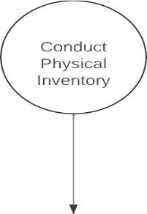

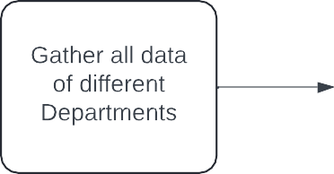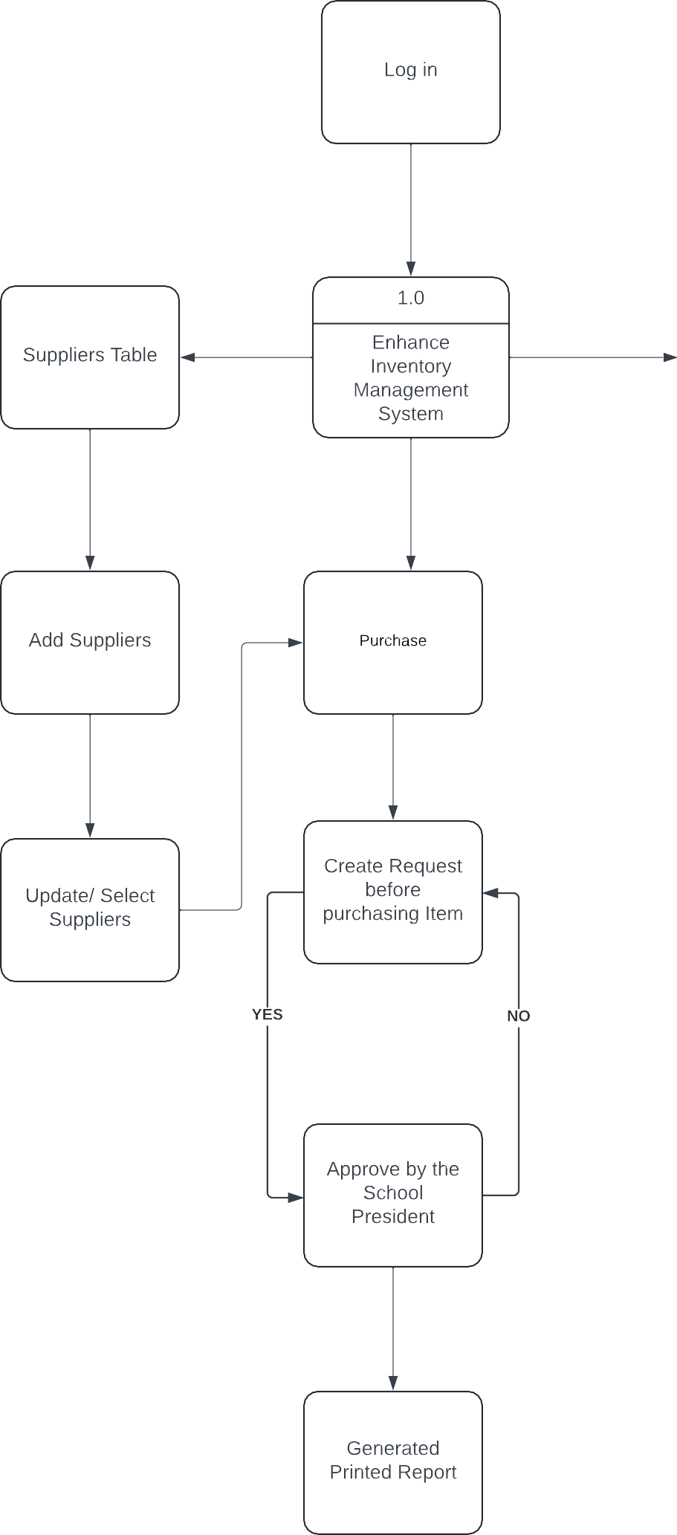

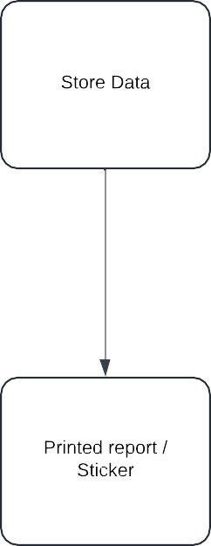

**Business Requirement Overview**

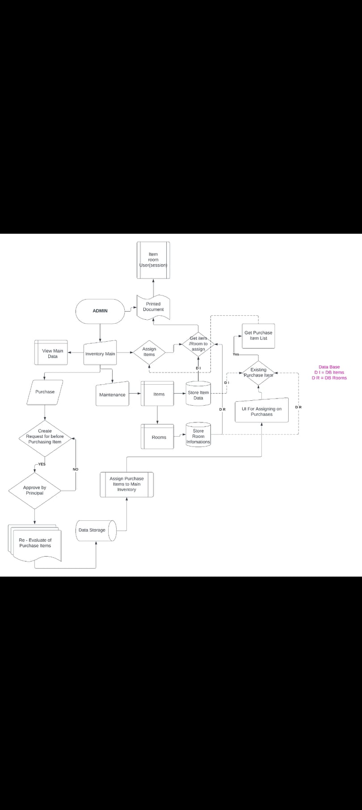 The figure shows the Business requirements overview of the proposed Enhance Inventory Management System.

**Business Solution**